CO1 ASSESMENT TOOL

Intelligent AI-Based Smart Banking Customer Service and Complaint Resolution System

NAME :JEROLD SAMUEL J
REG NO:192571052
DEPT: B.TECH CS BS
COURSE CODE : CSA-1017
SOFTWARE ENGINEERING

Introduction
The banking industry has undergone a significant digital transformation over the past decade due to rapid advancements in Information Technology (IT), Artificial Intelligence (AI), cloud computing, and mobile banking. Modern customers expect banking services to be available anytime and anywhere, with quick responses, secure transactions, and personalized support. As a result, banks receive thousands of customer inquiries, complaints, and service requests every day through multiple communication channels such as branch offices, call centers, mobile banking applications, internet banking portals, emails, social media platforms, and chat services. Managing these customer interactions efficiently has become one of the most critical challenges for financial institutions.
Customer satisfaction is one of the key indicators of a bank's success. When customers experience issues such as failed transactions, delayed fund transfers, loan-related queries, credit card disputes, account access problems, or fraudulent activities, they expect immediate assistance and quick resolution. However, many traditional banking customer service systems still rely on manual complaint registration, manual classification, and manual assignment of complaints to different departments. This approach often results in delayed responses, inconsistent complaint handling, duplicate records, human errors, poor communication, and longer resolution times. Consequently, customers become dissatisfied, leading to reduced trust, lower customer retention, and damage to the bank's reputation.
The increasing volume and complexity of customer complaints make it difficult for customer support teams to handle every issue manually while maintaining high service quality. Banks also face challenges in prioritizing urgent complaints, monitoring service-level agreements (SLAs), tracking complaint progress, and ensuring compliance with banking regulations. Without an intelligent system, complaints may be routed to the wrong department, critical issues may remain unresolved for extended periods, and management may lack accurate insights into customer service performance. Therefore, financial institutions require advanced technologies that can automate complaint management while improving operational efficiency and customer experience.
Another important component of AI-powered customer service is the implementation of intelligent chatbots. AI chatbots provide instant responses to customer inquiries without requiring human intervention. They can answer frequently asked questions, assist customers in registering complaints, provide real-time updates regarding complaint status, recommend solutions for common issues, and escalate complex cases to human support executives whenever necessary. Since chatbots operate 24 hours a day and seven days a week, they significantly reduce waiting times and improve customer convenience while decreasing the workload on customer service representatives.
In addition to complaint automation and chatbot assistance, modern AI-based banking systems utilize data analytics and business intelligence to monitor overall customer service performance. Advanced analytics help management identify common complaint categories, measure average resolution time, evaluate employee performance, monitor customer satisfaction scores, detect service bottlenecks, and predict future complaint trends. These insights enable banks to make informed business decisions, optimize resource allocation, improve service quality, and develop proactive strategies to prevent recurring issues.
The development of this system is best supported using the Agile Scrum Software Development Life Cycle (SDLC) methodology. Agile enables incremental development, continuous testing, regular customer feedback, and rapid adaptation to changing business requirements. Through iterative sprint cycles, new AI models, chatbot capabilities, and customer service features can be continuously improved without disrupting existing banking operations. This approach ensures higher software quality, faster deployment, and easier maintenance throughout the system's lifecycle.
The successful implementation of the Intelligent AI-Based Smart Banking Customer Service and Complaint Resolution System is expected to deliver numerous benefits to both customers and banks. Customers will experience faster complaint resolution, improved communication, personalized assistance, and greater transparency, while banks will benefit from reduced manual workload, enhanced operational efficiency, improved regulatory compliance, accurate service analytics, better decision-making, and increased customer loyalty. Ultimately, the proposed system will contribute to building a more intelligent, responsive, secure, and customer-centric banking environment capable of meeting the growing expectations of the digital era.

1. Problem Understanding
The existing banking complaint process depends on manual review by customer support teams. Customers often wait for acknowledgement, complaints are routed incorrectly, and managers have limited visibility into service performance. The proposed system aims to automate complaint registration, classify requests using NLP, assign priorities, route issues to the appropriate department, provide chatbot assistance, track resolution, and generate analytics. Scope includes retail banking customer complaints across mobile, web and branch channels while excluding core banking transaction processing. The existing banking complaint process depends on manual review by customer support teams. Customers often wait for acknowledgement, complaints are routed incorrectly, and managers have limited visibility into service performance. The proposed system aims to automate complaint registration, classify requests using NLP, assign priorities, route issues to the appropriate department, provide chatbot assistance, track resolution, and generate analytics. Scope includes retail banking customer complaints across mobile, web and branch channels while excluding core banking transaction processing. The existing banking complaint process depends on manual review by customer support teams. Customers often wait for acknowledgement, complaints are routed incorrectly, and managers have limited visibility into service performance. The proposed system aims to automate complaint registration, classify requests using NLP, assign priorities, route issues to the appropriate department, provide chatbot assistance, track resolution, and generate analytics. Scope includes retail banking customer complaints across mobile, web and branch channels while excluding core banking transaction processing. The existing banking complaint process depends on manual review by customer support teams. Customers often wait for acknowledgement, complaints are routed incorrectly, and managers have limited visibility into service performance. The proposed system aims to automate complaint registration, classify requests using NLP, assign priorities, route issues to the appropriate department, provide chatbot assistance, track resolution, and generate analytics. Scope includes retail banking customer complaints across mobile, web and branch channels while excluding core banking transaction processing.

2. Stakeholder Analysis
Stakeholders include Customers, Customer Support Executives, Complaint Resolution Officers, Branch Managers, Department Heads, IT Administrators, Bank Management and Regulatory Authorities. Customers register and track complaints. Support executives validate requests. AI classifies complaints. Managers monitor SLAs. Administrators maintain the platform. Executives analyse dashboards for service improvement. Stakeholders include Customers, Customer Support Executives, Complaint Resolution Officers, Branch Managers, Department Heads, IT Administrators, Bank Management and Regulatory Authorities. Customers register and track complaints. Support executives validate requests. AI classifies complaints. Managers monitor SLAs. Administrators maintain the platform. Executives analyse dashboards for service improvement. Stakeholders include Customers, Customer Support Executives, Complaint Resolution Officers, Branch Managers, Department Heads, IT Administrators, Bank Management and Regulatory Authorities. Customers register and track complaints. Support executives validate requests. AI classifies complaints. Managers monitor SLAs. Administrators maintain the platform. Executives analyse dashboards for service improvement. Stakeholders include Customers, Customer Support Executives, Complaint Resolution Officers, Branch Managers, Department Heads, IT Administrators, Bank Management and Regulatory Authorities. Customers register and track complaints. Support executives validate requests. AI classifies complaints. Managers monitor SLAs. Administrators maintain the platform. Executives analyse dashboards for service improvement.

3. Current System Analysis
Current systems depend on emails, call centres and manual ticket routing. Strengths include existing customer channels and experienced staff. Weaknesses include delayed responses, duplicate records, inconsistent prioritisation and poor visibility. Gap analysis shows the need for automation, AI classification, chatbot support, real-time tracking and analytics. Current systems depend on emails, call centres and manual ticket routing. Strengths include existing customer channels and experienced staff. Weaknesses include delayed responses, duplicate records, inconsistent prioritisation and poor visibility. Gap analysis shows the need for automation, AI classification, chatbot support, real-time tracking and analytics. Current systems depend on emails, call centres and manual ticket routing. Strengths include existing customer channels and experienced staff. Weaknesses include delayed responses, duplicate records, inconsistent prioritisation and poor visibility. Gap analysis shows the need for automation, AI classification, chatbot support, real-time tracking and analytics. Current systems depend on emails, call centres and manual ticket routing. Strengths include existing customer channels and experienced staff. Weaknesses include delayed responses, duplicate records, inconsistent prioritisation and poor visibility. Gap analysis shows the need for automation, AI classification, chatbot support, real-time tracking and analytics.

4. Proposed Software Solution
Modules include User Management, Complaint Registration, AI Classification Engine, Priority Prediction, Department Assignment, Chatbot, Resolution Tracking, Notification Service and Analytics Dashboard. The AI engine uses NLP to detect complaint category and urgency. Escalation rules ensure high-priority complaints reach the correct department immediately. Managers monitor dashboards showing SLA compliance, pending complaints and satisfaction scores. Modules include User Management, Complaint Registration, AI Classification Engine, Priority Prediction, Department Assignment, Chatbot, Resolution Tracking, Notification Service and Analytics Dashboard. The AI engine uses NLP to detect complaint category and urgency. Escalation rules ensure high-priority complaints reach the correct department immediately. Managers monitor dashboards showing SLA compliance, pending complaints and satisfaction scores. Modules include User Management, Complaint Registration, AI Classification Engine, Priority Prediction, Department Assignment, Chatbot, Resolution Tracking, Notification Service and Analytics Dashboard. The AI engine uses NLP to detect complaint category and urgency. Escalation rules ensure high-priority complaints reach the correct department immediately. Managers monitor dashboards showing SLA compliance, pending complaints and satisfaction scores. Modules include User Management, Complaint Registration, AI Classification Engine, Priority Prediction, Department Assignment, Chatbot, Resolution Tracking, Notification Service and Analytics Dashboard. The AI engine uses NLP to detect complaint category and urgency. Escalation rules ensure high-priority complaints reach the correct department immediately. Managers monitor dashboards showing SLA compliance, pending complaints and satisfaction scores. Modules include User Management, Complaint Registration, AI Classification Engine, Priority Prediction, Department Assignment, Chatbot, Resolution Tracking, Notification Service and Analytics Dashboard. The AI engine uses NLP to detect complaint category and urgency. Escalation rules ensure high-priority complaints reach the correct department immediately. Managers monitor dashboards showing SLA compliance, pending complaints and satisfaction scores.

Architecture Components

Layer | Components | Purpose
Presentation Layer | Web Portal, Mobile Banking App, Branch Portal | Allows customers to register and track complaints.
Security Layer | Authentication, Multi-Factor Authentication (MFA), Role-Based Access Control | Ensures secure access to the system.
AI Complaint Management Layer | Complaint Registration, NLP Classification, AI Chatbot, Priority Prediction, Routing Engine | Automates complaint handling and customer support.
Business Logic Layer | Customer Support, Resolution Team, Fraud Department, Loan Department | Processes and resolves customer complaints.
Data Layer | Customer Database, Complaint Database, Analytics Database | Stores complaint records and generates reports.
Management Layer | Admin Dashboard, Analytics Dashboard | Monitors performance, generates reports, and supports decision-making.

Architecture Diagram

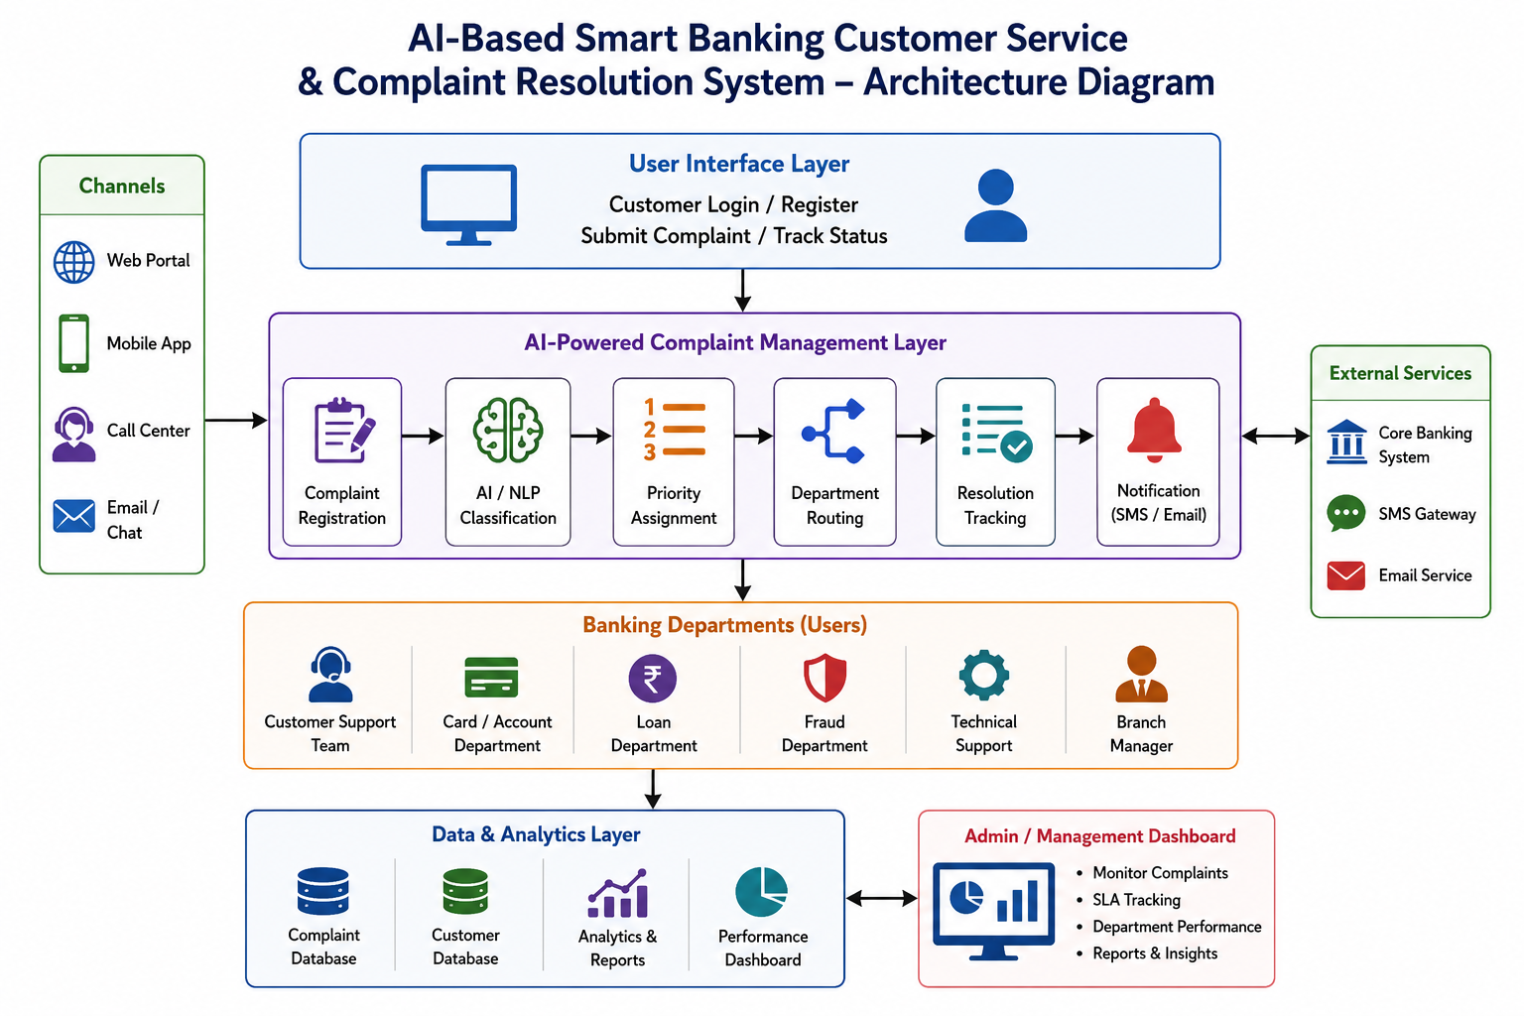

Functional Requirements
1. Secure login.
2. Register complaints.
3. Upload supporting documents.
4. AI complaint classification.
5. Intelligent prioritisation.
6. Automatic routing.
7. Complaint tracking.
8. Notifications.
9. Dashboard.
10. Report generation.

Non-Functional Requirements
Security using encryption and RBAC; Availability 24x7; Reliability through backups; Scalability using cloud deployment; Maintainability with modular architecture; Performance with fast response time; Usability through simple UI; Auditability through logs. Security using encryption and RBAC; Availability 24x7; Reliability through backups; Scalability using cloud deployment; Maintainability with modular architecture; Performance with fast response time; Usability through simple UI; Auditability through logs. Security using encryption and RBAC; Availability 24x7; Reliability through backups; Scalability using cloud deployment; Maintainability with modular architecture; Performance with fast response time; Usability through simple UI; Auditability through logs.

Software Engineering Principles
Modularity separates chatbot, AI engine and complaint services. Scalability supports increasing users. Maintainability uses layered architecture and documentation. Reliability includes validation and backups. Security uses encryption, MFA and role-based access. Usability focuses on intuitive interfaces. Reusability is achieved through APIs. Testability uses unit, integration and system testing. Modularity separates chatbot, AI engine and complaint services. Scalability supports increasing users. Maintainability uses layered architecture and documentation. Reliability includes validation and backups. Security uses encryption, MFA and role-based access. Usability focuses on intuitive interfaces. Reusability is achieved through APIs. Testability uses unit, integration and system testing. Modularity separates chatbot, AI engine and complaint services. Scalability supports increasing users. Maintainability uses layered architecture and documentation. Reliability includes validation and backups. Security uses encryption, MFA and role-based access. Usability focuses on intuitive interfaces. Reusability is achieved through APIs. Testability uses unit, integration and system testing. Modularity separates chatbot, AI engine and complaint services. Scalability supports increasing users. Maintainability uses layered architecture and documentation. Reliability includes validation and backups. Security uses encryption, MFA and role-based access. Usability focuses on intuitive interfaces. Reusability is achieved through APIs. Testability uses unit, integration and system testing.

5. Agile Scrum Justification
Agile Scrum is appropriate because requirements evolve with customer feedback. Product backlog items are implemented in short sprints. Sprint planning, daily stand-ups, reviews and retrospectives improve quality. Continuous integration and testing reduce defects and support incremental delivery. Agile Scrum is appropriate because requirements evolve with customer feedback. Product backlog items are implemented in short sprints. Sprint planning, daily stand-ups, reviews and retrospectives improve quality. Continuous integration and testing reduce defects and support incremental delivery. Agile Scrum is appropriate because requirements evolve with customer feedback. Product backlog items are implemented in short sprints. Sprint planning, daily stand-ups, reviews and retrospectives improve quality. Continuous integration and testing reduce defects and support incremental delivery. Agile Scrum is appropriate because requirements evolve with customer feedback. Product backlog items are implemented in short sprints. Sprint planning, daily stand-ups, reviews and retrospectives improve quality. Continuous integration and testing reduce defects and support incremental delivery.

6. Expected Outcomes and Limitations
Benefits include faster complaint resolution, improved customer satisfaction, reduced manual workload, accurate analytics and better operational efficiency. Risks include AI misclassification, implementation cost, employee training and cybersecurity threats. Future enhancements include multilingual chatbots, voice assistants, predictive analytics and generative AI support. Benefits include faster complaint resolution, improved customer satisfaction, reduced manual workload, accurate analytics and better operational efficiency. Risks include AI misclassification, implementation cost, employee training and cybersecurity threats. Future enhancements include multilingual chatbots, voice assistants, predictive analytics and generative AI support. Benefits include faster complaint resolution, improved customer satisfaction, reduced manual workload, accurate analytics and better operational efficiency. Risks include AI misclassification, implementation cost, employee training and cybersecurity threats. Future enhancements include multilingual chatbots, voice assistants, predictive analytics and generative AI support. Benefits include faster complaint resolution, improved customer satisfaction, reduced manual workload, accurate analytics and better operational efficiency. Risks include AI misclassification, implementation cost, employee training and cybersecurity threats. Future enhancements include multilingual chatbots, voice assistants, predictive analytics and generative AI support.

Conclusion
The Intelligent AI-Based Smart Banking Customer Service and Complaint Resolution System offers an innovative and efficient solution to improve the quality of banking customer service. By integrating Artificial Intelligence (AI), Natural Language Processing (NLP), intelligent chatbots, and data analytics, the proposed system automates the complete complaint management process, from complaint registration to final resolution. This reduces manual effort, minimizes human errors, and ensures faster and more accurate complaint handling.
The system enables customers to register complaints through multiple digital channels, receive instant support from AI-powered chatbots, track complaint status in real time, and obtain timely updates throughout the resolution process. At the same time, banking staff and managers can efficiently monitor complaints, prioritize critical issues, assign cases to the appropriate departments, and analyze service performance using interactive dashboards and reports. These features help improve operational efficiency, maintain service quality, and support better decision-making.
From a software engineering perspective, the proposed solution follows important principles such as modularity, scalability, maintainability, reliability, usability, and security, making it suitable for future enhancements and increasing customer demands. The adoption of the Agile Scrum methodology further supports continuous development, regular feedback, and efficient system maintenance.
Overall, the proposed system addresses the limitations of traditional complaint management by providing a secure, intelligent, and customer-centric platform. It is expected to improve response time, increase customer satisfaction, reduce operational costs, enhance banking efficiency, and strengthen the bank's reputation. With future advancements such as predictive analytics, multilingual chatbot support, and advanced AI capabilities, the system can continue to evolve and meet the growing expectations of modern digital banking.

References
- R. S. Pressman and B. R. Maxim, Software Engineering: A Practitioner's Approach, 9th ed. New York, NY, USA: McGraw-Hill Education, 2020.
- Sommerville, Software Engineering, 10th ed. Boston, MA, USA: Pearson Education, 2016.
- S. Russell and P. Norvig, Artificial Intelligence: A Modern Approach, 4th ed. Hoboken, NJ, USA: Pearson, 2021.
- D. Jurafsky and J. H. Martin, Speech and Language Processing, 3rd ed. (Draft). Stanford University, 2023.
- T. H. Davenport and R. Ronanki, "Artificial Intelligence for the Real World," Harvard Business Review, vol. 96, no. 1, pp. 108–116, Jan.–Feb. 2018.
- M. Fowler, UML Distilled: A Brief Guide to the Standard Object Modeling Language, 3rd ed. Boston, MA, USA: Addison-Wesley, 2004.
- International Organization for Standardization, ISO/IEC 25010:2011 – Systems and Software Engineering – Systems and Software Quality Requirements and Evaluation (SQuaRE) – System and Software Quality Models, Geneva, Switzerland, 2011.
- IEEE Computer Society, IEEE Std 830-1998: IEEE Recommended Practice for Software Requirements Specifications, New York, NY, USA: IEEE, 1998.
- K. Schwaber and J. Sutherland, The Scrum Guide: The Definitive Guide to Scrum – The Rules of the Game, Scrum.org, 2020.
- P. Jackson, Introduction to Expert Systems, 3rd ed. Harlow, UK: Addison-Wesley, 1998.

